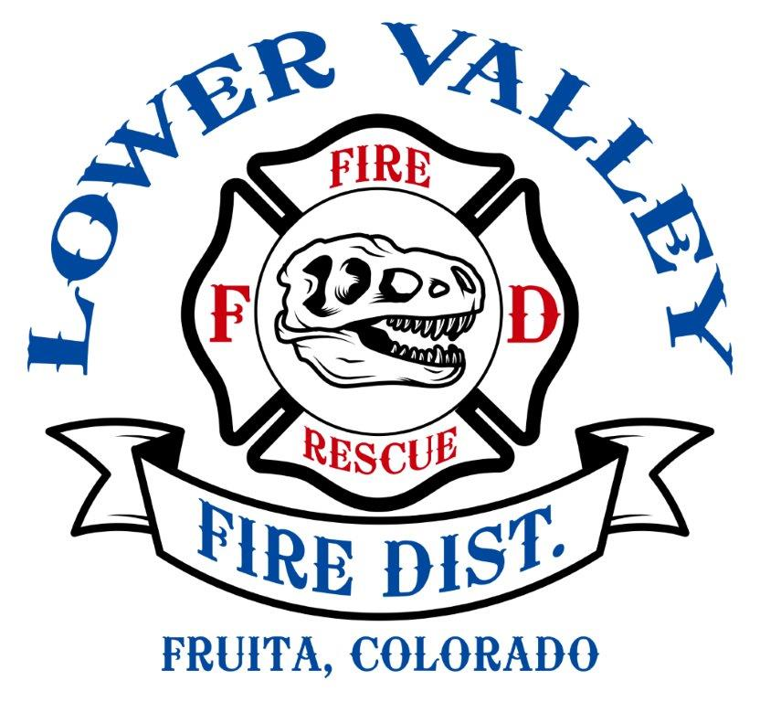
168 N. Mesa St. Fruita, Co. 81521
970-858-3133 phone 970-858-7189 fax

Lateral Hire for Full Time Firefighter Paramedic
Hiring Range - $77,212.60 - $83,076.65 DOQ

The Lower Valley Fire Protection District is seeking a full-time Firefighter Paramedic on Mesa County EMS Protocol. We will be accepting applications to fill a current vacancy and to establish a pool for future candidates. We are looking for forward-minded individuals that work well within a team environment in stressful situations.

MINIMUM QUALIFCATIONS:

- Citizen of the United States of America and at least 18-years of age
- High School diploma or general equivalency diploma (GED)
- Valid Colorado driver’s license
- Current Colorado Paramedic certification on Mesa County EMS protocol.
- Firefighter I, Hazardous Materials Operation, NIMS 700-800, ICS100-200, S-130 S-190, L-180.
- Sound physical health and mentally fit to perform firefighting and emergency medical duties.

BENEFIT PACKAGE:

  - 100% employer paid for employee and family (CEBT EPO3 with PPO3 plan optional)
  - $20,000 Life Insurance- employer paid.
  - Optional Dental, Vision, Supplemental Life Insurance
  - 10 Paid Holidays
  - Short-term disability.
  - 48/96 work schedule.
  - 67.2 hours per year of sick time accrued.
  - 164.4 hours per year of paid time off accrued.
  - Employee Assistance Program
  - Employer match FPPA defined retirement plan.
APPLICATION PROCESS:
Interested applicants can pick up an application packet from the administration offices between 8:00am-4:00pm Monday through Friday. Applications are also available on our website lowervalleyfire.com under the Employment tab. For more information, contact Frank Cavaliere, Fire Chief at 970-858-3133 extension 1 or Matt Katzenberger, Deputy Chief at 970-858-3133 extension 5.

Return completed application containing resume, cover letter, and all required attachments to administration offices by 4:00pm on June 14th, 2024.

SELECTION PROCESS & SCHEDULE:
- Modified combat challenge physical ability testing and interview panels June 27th with Chief’s interview to be announced after testing.
- Criminal history background check- Completed following Chief’s interview.
- Medical physical exam- Due within 2 weeks of receiving conditional offer.
- Drug and alcohol screening- Due within 2 weeks of receiving conditional offer.

