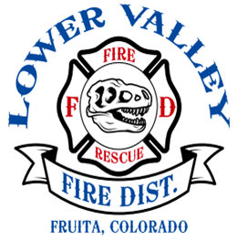

LOWER VALLEY FIRE PROTECTION DISTRICT
TEMPORARY EVENT PERMIT
$ 100.00 PERMIT FEE

The applicant hereby requests a permit to conduct an event within the Lower Valley Fire Protection District, subject to the following requirements, together with all legal requirements that may apply.

Applicant is required to furnish the following information before a permit will be issued:

DATE(S) OF EVENT

Name of Applicant:

Address of Applicant:

City: State: Zip Code:

Contact Information: Phone E-mail

Address or location of Event:

Attach copy of site plan and information on LP gas, generators, tent/canopy and any Colorado Department of Public Safety – Colorado Division of Fire Prevention & Control License /Certification(s). if required.

Liability Insurance shall be procured and maintained by the event sponsor at its own cost in the amount not less than $1,000,000 General Liability Insurance per occurrence. A copy of the policy shall be provided to the Fire District. The Lower Valley Fire Protection District must be listed as additional insured on the policy.
INSPECTION REQUIREMENTS
A Fire Department inspection of the event area is required. Call: (970)-858-3133 to schedule time. A minimum of 24-hour notice is required.
Tents and operations shall comply with the requirements of Chapter 31 of the Fire Code or Safety Requirements for Temporary Events.
I have read and understand the requirements of this application.
Applicant Signature Date:

Lower Valley Fire Protection District Authorization: Date:
Revised 9/22/2021, Ref: 2018 IFC Section 105

