Fire Sprinkler System Plan
Review & Acceptance Testing
Issued: December 2020

If you have any questions or comments regarding the information contained within, or if you need assistance interpreting these requirements, please contact:

168 North Mesa
Fruita, Colorado 81521
Tel: (970) 858-3133
Website: lowervalleyfire.com.
Email: postmaster@lvfdfire.org

Table of Contents

Minimum Requirements 2
Small Project Submittals 4
Plan Review Submittal Matrix 5
Final Inspection and Acceptance Testing 5
Code References 5

Minimum Requirements

FIRE SPRINKLER SYSTEM WORKING PLANS AND ASSOCIATED DOCUMENTS, INCLUDING “SMALL PROJECT” DOCUMENTS SHALL BE SUBMITTED TO THE AUTHORITY HAVING JURISDICTION (AHJ), THE LOWER VALLEY FIRE DISTRICT, FOR REVIEW AND APPROVAL PRIOR TO SYSTEM INSTALLATION OR OTHER WORK BEING COMPLETED (2018 IFC SEC. 901.2 AND 2016 NFPA 13 SEC. 23.1.1)

Fees: Will be assessed upon the conclusion of the plan review according to the locally adopted fee schedule.

Designer Information: All plan drawings and hydraulic calculations shall be prepared and signed/dated by a designer who is a Colorado Registered Professional Engineer (P.E.) or a NICET Level III or NICET Level IV. The designer of the system shall be clearly identified on the documents (Colorado Division of Fire Safety). Any individual or company who physically works on or installs any part of a fire protection system, including underground supply lines and back flow preventers must be registered with the Colorado Division of Fire Safety.

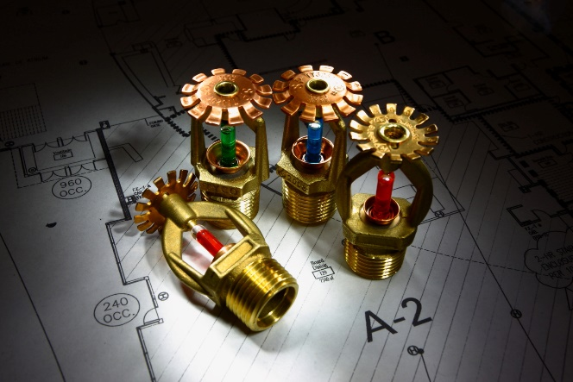
Permit application and a minimum of two sets of the following:
• Complete set of plans
• Equipment specification sheets
• Hydraulic calculations

ALL WORKING PLAN SUBMITTALS SHALL CONTAIN RELEVANT INFORMATION AS LISTED IN 2016 NFPA 13 SEC. 23.1.3.

ITEMS OF PARTICULAR CONCERN THAT SHOULD BE IDENTIFIED IN THE SUBMITTAL INCLUDE:

Water Supply Information: Working plans shall include static pressure (psi), residual pressure (psi), flow (gpm), date of test, name of organization who conducted test or supplied information. Fire flow testing utilized for the purpose of design review shall be conducted no more than 12 months prior to working plan submittal (2016 NFPA 13 SEC. 23.2.1.1, Colorado Division of Fire Safety). Location of the fire hydrants utilized for the fire flow test must be accepted by the AHJ. Flow tests completed by the contractor must be witnessed by the AHJ.

Water Supply Graph: The first curve shall indicate actual water flow information. A second curve shall visually represent a 10% safety factor reduction. This curve shall be separate and distinguishable from the actual water flow curve and have a slope equal to or greater than the actual water flow curve. The hydraulic design shall be below the adjusted water supply curve (10% requirement is consistent with Colorado Division of Fire Safety Rules).

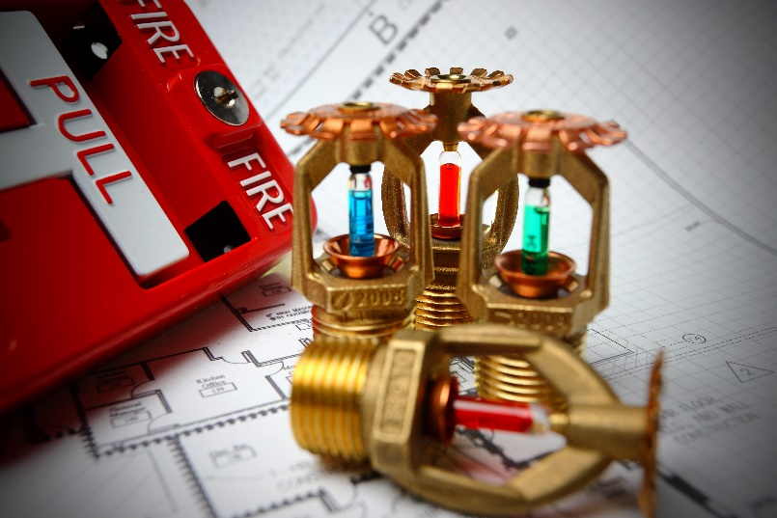
Omitted Coverage Areas: Note location and size of concealed spaces, closets, attics, bathrooms, small enclosures, balconies, canopies, etc. that do not contain proposed fire sprinkler coverage. List applicable code section on plans. Areas covered by alternative fire protection equipment should also be noted (i.e. clean agent system).

Underground: Each set of plans shall accurately indicate locations and dimensions of water mains, test hydrant, flow hydrant, firelines, and any other applicable information. Hydraulic calculations should be completed all the way back to the fire hydrant or other water source where the fire flow test was conducted.

Equipment Specification Sheets: Equipment utilized in the design shall be clearly identifiable in the submitted specification sheets by either highlight or marking.

Owner’s Certificate: A signed copy of the owner’s certificate shall be submitted with all new full plan submittals and submittals involving occupancy change of use (2016 NFPA 13 SEC. 23.1.4)

Working Plan Re-Submittals: Submittals requiring additional information shall be placed “On Hold” until required information has been submitted. If a re-submittal is required, MINOR plan information revisions shall be submitted with changes clouded. Changes involving a complete system re-design need not be clouded. Changes in other documents shall be clearly identified.

Non-Required Systems: All proposed non-required fire sprinkler systems shall meet the same requirements for required systems and meet locally adopted codes (i.e. International Fire Code, NFPA 13, etc.). The “Non-Required” fire sprinkler system shall be submitted for review and acceptance to the AHJ (2018 IFC SEC. 901.4.2). Freezing Conditions: It is the designer’s responsibility to provide the building’s owner with a system design that will continue to function reliably even under adverse temperature conditions. The sprinkler contractor must be conscious of field conditions that may affect the performance of the system and make corrections as required. It is the owner’s responsibility to ensure adequate heat is provided to the building.

Flex Connections: Systems utilizing flexible sprinkler head connections shall be listed and approved for use by the AHJ regardless of the project scope of work and installed in accordance with manufacturer specifications. The amount of bends in the flexible connections shall correspond to manufacturer’s requirements. Bend tools and manufacturer directions are to remain on site.

Hydrostatic Test: All piping and joints, including the FDC piping, standpipe and/or sprinkler systems require a 200-psi hydrostatic test for 2 hours per NFPA 13 and NFPA 24. Where system working pressure exceeds 150 psi, the hydrostatic test shall be performed at 50 psi in excess of the system working pressure per NFPA 13. The test shall be witnessed and accepted by the AHJ (2016 NFPA 13 SEC. 25.2.1.2). System modifications involving 20 or fewer sprinkler heads shall not require testing in excess of system working pressure.

Pre-Test: A full 100% pre-testing of the fire sprinkler system to include inspector’s tests, main drain, supervisory tampers and applicable trip tests (i.e. dry systems) are required to be completed by the contractor prior to scheduling the final inspection and acceptance testing with the AHJ. A statement of compliance is required as a result.

Statement of Compliance: Where required, documentation must be submitted to the AHJ in written format and signed by the contractor (i.e. letter) documenting the system has been pre-tested and installed prior to final inspection in accordance with approved plans, International Fire Code (2018 ed.), NFPA 13 (2016 ed.), manufacturers specifications and/or any other applicable code or design standard documents.

Final Inspection Scheduling: Final Inspection requests for most major projects (i.e. new buildings) will not be granted until both the Fire Sprinkler and Fire Alarm contractor make the request and state, they are ready for acceptance testing. The fire sprinkler contractor may call for final inspections when the project only involves a fire sprinkler system (i.e. tenant finish). Requests for inspections require a minimum 48 hours notice.

Contractor’s Material and Test Certificate for Above-ground Piping: Document shall be submitted to the AHJ upon completion of the final inspection. A copy of the “Contractor’s Material and Test Certificate for Above-ground Piping” may be found in NFPA 13 (2016 NFPA 13 SEC. 25.1).

Permits On-Site: An approved set of plans, including comments and conditions of approval by the AHJ, shall be made available on-site while work is being completed (2018 IFC 105.3.5).
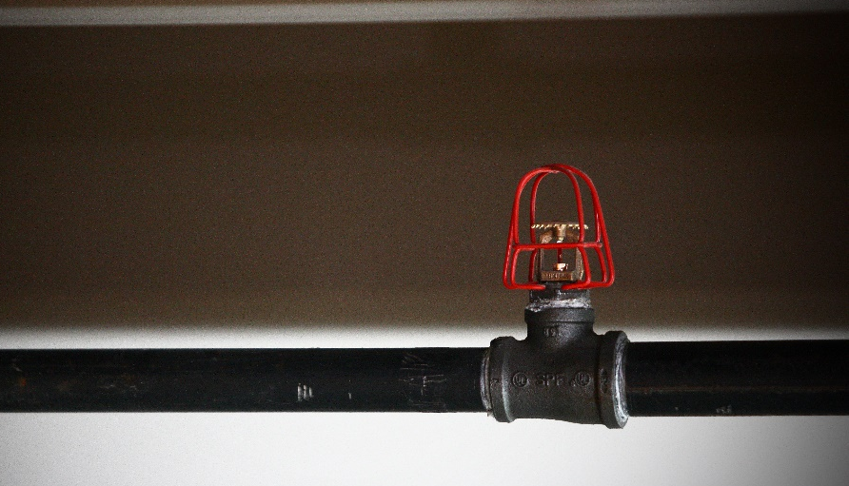

As-Built Plans: Significant deviations from the approved “working plans” during the installation of the fire sprinkler system shall require permission from the AHJ and may require submittal of revised drawings/documents (2018 IFC SEC 105.3.6). The submission of “as built” plans upon the project’s completion may be required and is at the discretion of the AHJ (2018 IFC SEC 901.2, 2016 NFPA 13 SEC. 23.1.2).

Small Project Submittals

“Small Projects” are defined as any work involving the addition or relocation of less than 20 sprinkler heads. Work related to small projects cannot have an adverse affect on the integrity of the existing fire protection system, including hydraulic design. All materials and equipment installed must be listed. A full plan review is not required for small projects, unless the AHJ requires a full submittal.
The “Small Project” letter on company letterhead or in official email shall include the following information: Project name, address, anticipated start and completion dates, project scope of work, number of sprinkler heads, and a statement indicating there will be no adverse hydraulic effects on the system’s remote area or demand.
Submittal of hydraulic calculations and equipment specification sheets for projects with less than 20 sprinkler heads are at the discretion of the AHJ. All installations require an AHJ rough-in and final inspection regardless of the number of heads altered or installed. Contractors are required to call for inspections prior to work being covered. This excludes minor repairs and maintenance issues associated with existing systems.

Plan Review Submittal Matrix
 | Permit Form | Full Plan  Review Submittal | Small Project Letter | Small  Project Drawing  (i.e. PDF, 8x11)
New Fire sprinkler System | X | X
20 or more Sprinkler Heads | X | X
Small Project (six to 19 Sprinkler Heads) |  |  | X | X
Small Project (five or fewer Sprinkler Heads) |  |  | X

Final Inspection and Acceptance Testing

Systems shall undergo acceptance testing witnessed by the AHJ. It shall be the duty of the contractor to schedule the inspection (2018 IFC SEC. 901.5).
It shall be unlawful to occupy any portion of a building or structure until the required fire protection system(s) have been tested and accepted by the AHJ (2018 IFC SEC. 901.5.1).
Rough-In Inspection: Sprinkler piping and hangers shall not be covered and/or concealed by any means prior to a visual inspection by the AHJ including drop grid ceilings. Ceilings, including finished sheetrock, may be required to be removed if necessary, for inspection (2018 IFC SEC. 107).

Code References

International Fire Code (2018 Edition)
NFPA 13 (2016 Edition)
NFPA 13R (2016 Edition)
NFPA 13D (2016 Edition)
NFPA 25 (2017 Edition)
Local & State Regulations

